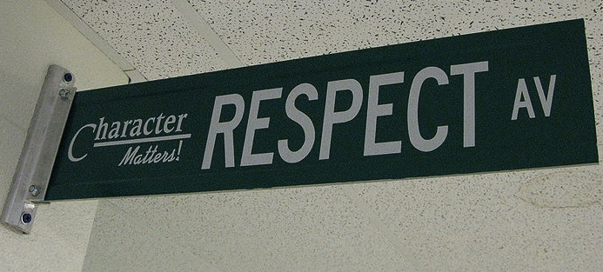
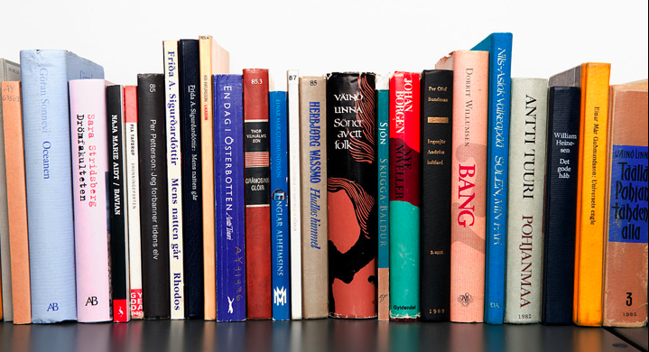
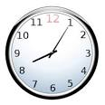

Homework
Homework is not busywork. It is necessary for you to complete in order to participate in class the next day or to develop important skills. You will be given a calendar of homework assignments quarterly to help you keep track of your assignments. If you choose not to complete the assigned work, you are missing out on the opportunity to learn and grow. In the past, students who didn’t complete homework struggled to pass English 9, while students who regularly completed homework succeeded. Homework assignments may include, but are not limited to:
- Independent reading
- Drafting, revising, and writing polished pieces of writing
- Vocabulary activities
- Responding to articles or writing prompts
- Reader’s response journals
Welcome to MYP English 9. Our goal for the year is to learn to read and think as writers, to look at texts through a writer’s eye. We will be reading and writing poetry, narratives, informational, and argumentative texts. You will have the opportunity to read engaging, thought-provoking texts and novels you won’t want to put down. By examining these exemplary texts, you will build your skills as a writer and be able to communicate your ideas effectively. We will also spend time building your vocabulary and grammar skills. Discussion, both speaking and listening, as well as working in collaboration with others will play a large role in class and help to prepare you for the college and career world. I look forward to spending the year learning with you!

Be kind & be respectful.

Class Expectations

Follow directions the first time they are given.

Raise your hand and wait to be called on before speaking.
All school rules also apply.

Turn phone off during instruction.

Be on time & be prepared.

Course Description

Grades will be based on Minnesota Academic Standards for English Language Arts AND IB-MYP Assessment Criteria. The Minnesota standards and MYP objectives will be translated into weekly/daily Learning Targets that will help measure the quality of student work. Standards being tested will fall into the four major categories for Minnesota ELA/MYP Standards:
Criterion A: Analysis (Reading Skills)
How well does the student
- analyze the content, context, language, structure, technique and style of text(s) and the relationship among texts
- analyze the effects of the creator’s choice on an audience
- justify opinions and ideas, using examples, explanations, and terminology
- evaluate similarities and differences by connecting features across and within genres
Criterion B: Organization (Writing/Presenting)
How well does the student
- employ organizational structures that serve the context and intention
- organize opinions and ideas in a sustained, coherent and logical manner
- use referencing and formatting tools to create a presentation style suitable to the context and intention
Criterion C: Producing Text (Creative writing/projects)
How well does the student
- produce texts that demonstrate insight, imagination and sensitivity while exploring and reflecting critically on new perspectives and ideas arising from personal engagement with the creative process
- make stylistic choices in terms of linguistic, literary and visual devices, demonstrating awareness of impact on an audience
- select relevant details and examples to develop ideas
Criterion D: Using Language (Presenting/Listening/Viewing/Grammar/Punctuation)
How well does the student
- use appropriate and varied vocabulary, sentence structures and forms of expression
- write and speak in a register and style that serve the context and intention
- use correct grammar, syntax and punctuation
- spell, write, and pronounce with accuracy
- use appropriate non-verbal communication techniques
Approaches to Learning
- Communication
- Social Skills
- Collaboration
- Organization
- Reflection
- Self-Management

PLEASE IGNORE PERCENTAGES in gradebook! For example, a score of 4 is NOT 50% or an F; it is a C!! Just look at your number scores and find the mode. That will show your grade.
The above criteria will be used to report grades earned. For each assignment, you will receive a score 1-8.
GRADE SCALE
- A Majority 8s, no grades under 6.
- A- Majority 7s, no grades under 5.
- B Majority 6s, no grades under 4. No missing summative assessment
- B- Majority 5s, no grades under 3. No missing summative assessment
- C Majority 4s, no grades under 2.
- C- Majority 3s, no grades under 2.
- D Majority 2s.
- F Majority 1s or Incompletes

Your summative assessments will be worth more towards your grade as they display the results of your unit-long learning. About 25% of the scores will be formative scores (homework, quizzes, warm-ups) and about 75% of the scores will be summative scores (projects, papers & presentations).

Academic Integrity: Plagiarism/Consequences
It is expected that members of this class will observe strict policies of academic honesty and will be respectful of each other. Any instances in which cheating, including plagiarism and unauthorized use of copyrighted materials, computer accounts, or someone else’s work is determined, the matter will be investigated. If plagiarism is verified, student will receive a zero for the assignment and will be referred to their Assistant Principal.

Student Code of Conduct
All students are expected to adhere to the Southwest High School and Minneapolis District Citywide Discipline Policy, designed to promote a safe and respectful learning environment. For more information about your rights and responsibilities consult your Southwest Student/Parent Handbook
Entering Class: Gather any necessary materials, quickly find your seat, and begin working on the warm-up posted on the board. This is a timed five-minute activity.
Bathroom Usage: Schoolwide policy states students may not leave class in the first or last TEN minutes. A schedule is posted in the classroom. You must have a hall pass.
Food & Electronic Devices: Food and drink (without lids) are not permitted outside of the cafeteria for sanitary reasons. Electronics should not be seen or heard in the classroom-during instruction.
Exiting Class: In the last five minutes of class, you will wrap up what you are working on, return materials to the appropriate locations, and turn homework. The teacher, not the bell, dismisses you upon completion of these tasks.
Absences: If you are absent, it is your responsibility to make up missed assignments. See the “While You Were Out” Purple folders for handouts. Talk to your study buddies.
Revise & Redo: Many assignments, especially our writing pieces, will require multiple attempts. An assignment is not considered complete and will not be graded until it meets the checklist criteria for that assignment.

Positive & Negative Consequences
Meeting classroom expectations and behaving appropriately in class helps to create a learning environment where you and your classmates feel welcome, safe, and respected.
If you choose to meet the classroom expectations, you will receive a positive consequence, such as praise from teacher, classmates, administration, “Shout Outs,” a positive note or phone call home, a fun learning environment, awards, etc.
If you choose not to meet the classroom expectations, you will receive a negative consequence, such as a verbal warning, a change of seat, a student/teacher conference, a phone call home, a detention, a parent/guardian meeting, and for severe infractions of school rules, suspension.

YOU WILL NEED:
- A composition book & folder.
- Writing utensils (pens or pencils)
- A set of colored highlighters
- A backpack or bag to carry your supplies
- A student Gmail account (sign up for one if you don’t have one already)
- A positive attitude, a sense of humor, & an open mind

Classroom Policies & Procedures

