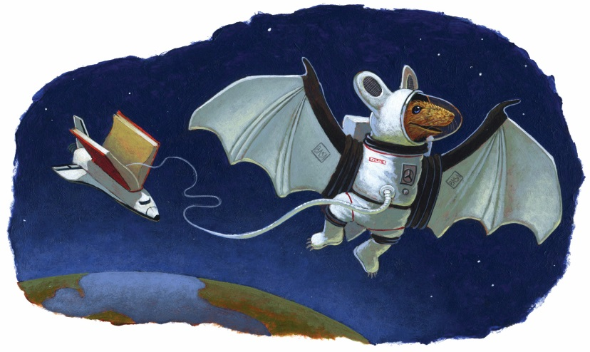

Independent-Reading Project

Quarter 4

Due Date: 10/31/2017
Name:_________
Hour:_______
Directions: For the duration of the quarter, you will read an additional book of your choice. Start with your interests or hobbies. All of you have subjects you are passionate about (Sports, music, history, computers, relationships, cars, celebrities, skateboarding, serial killers, video gaming, etc.). One of the best ways to figure out what you love is to ask yourself which television shows or movies you enjoy the most. Once you select a book, you will be expected to monitor your reading comprehension, speed, fluency and vocabulary acquisition.
I have chosen___________________________________________________________________
(title)
by ______________________________________________________________________.
(author)
Have you read this book before? *Note: You CAN NOT re-read a book you have read before.

The reasons I want to read this book are
1. ____________________________________________________________________________

2. ____________________________________________________________________________

I understand that to finish my book by the deadline of ____________, I must read ________
pages a day. I agree to read ____________pages a week.
____________________________________________________________ Date _____________
(Student Signature)

Reading Log

Book Title & Author:
Date | Pages read this day. | Pages read out of class. | How well did you stay focused today? | Interesting quotes or interesting attention grabbers I found…

Final Project Options

Directions: Choose ONE of the following interesting projects or propose your own project idea to Ms. Mohamud. Creativity is HIGHLY ENCOURAGED!

- Movie Poster…Create a movie poster for your book! Set the story in a different time period or era, and explain why you chose this time period.
Note: This project does NOT need to be more than 1-2 pages, including photos.
- We the People: Examine the book from the point of view of a specific organization: Choose a group that may oppose or praise the actions of characters in the novel. For instance, in Absolutely True Diary of a Part-Time Indian, Rowdy is physically abused by his father. The National Resource Center for Child Protective Services might condemn the actions of Rowdy’s father.
Which media platform might your selected organization use? For instance, will they release a press conference, write a newspaper article, or go on a specific Show? Whichever platform you choose, make sure that you ACTUALLY WRITE their message.

- Talk Show Invitation. Select a character and think about his or her life experiences; then figure out which talk show would most want your character on as a guest. What would they want the character to talk about? Who else would they invite on the show to address the issues the character is involved in? Write up an email exchange between the talk show host and the character in which the host explains what the character should focus on while on the show.
*Write the FICTITIOUS exchange. Do not just tell us what they WOULD say. Show us!
- Graphic Novel Panels: Create a series of six panels (I’ll explain how to design panels in class.) that show significant turning points in the novel. Under each panel, in one word, explain the significance of the picture.
- Future Career: Choose a character from the novel. Google some personality tests online and take the test AS YOUR CHARACTER. Which profession should your character look into? Was the test accurate? Explain.
- Themes of Life: Choose a theme or two and track them throughout the novel. Examples of themes: Love, perseverance, loyalty, confidence. Choose a couple of songs that also express that theme, and in one page compare the songs and book themes.
- Dear Diary: Choose a character to track. Buy a diary or journal for your character, and write a total of 10 entries about what your character is feeling, thinking, hiding, etc.
- Children’s Book: Write 6-10 illustrated pages explaining the plot and major themes of the novel.

